The github link is currently not opening in a new tab like linkedin – have this also open in a new tab to stop traffic being directed away from your portfolio

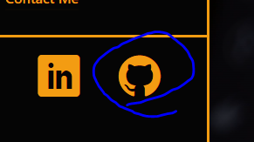

Add the ability to open your Netmatters site on the subdomain on the server – so an employer can see it in action.

Add explanation to your Coding example to show to a potential employer you understand how it works, not just copied it from somewhere else.

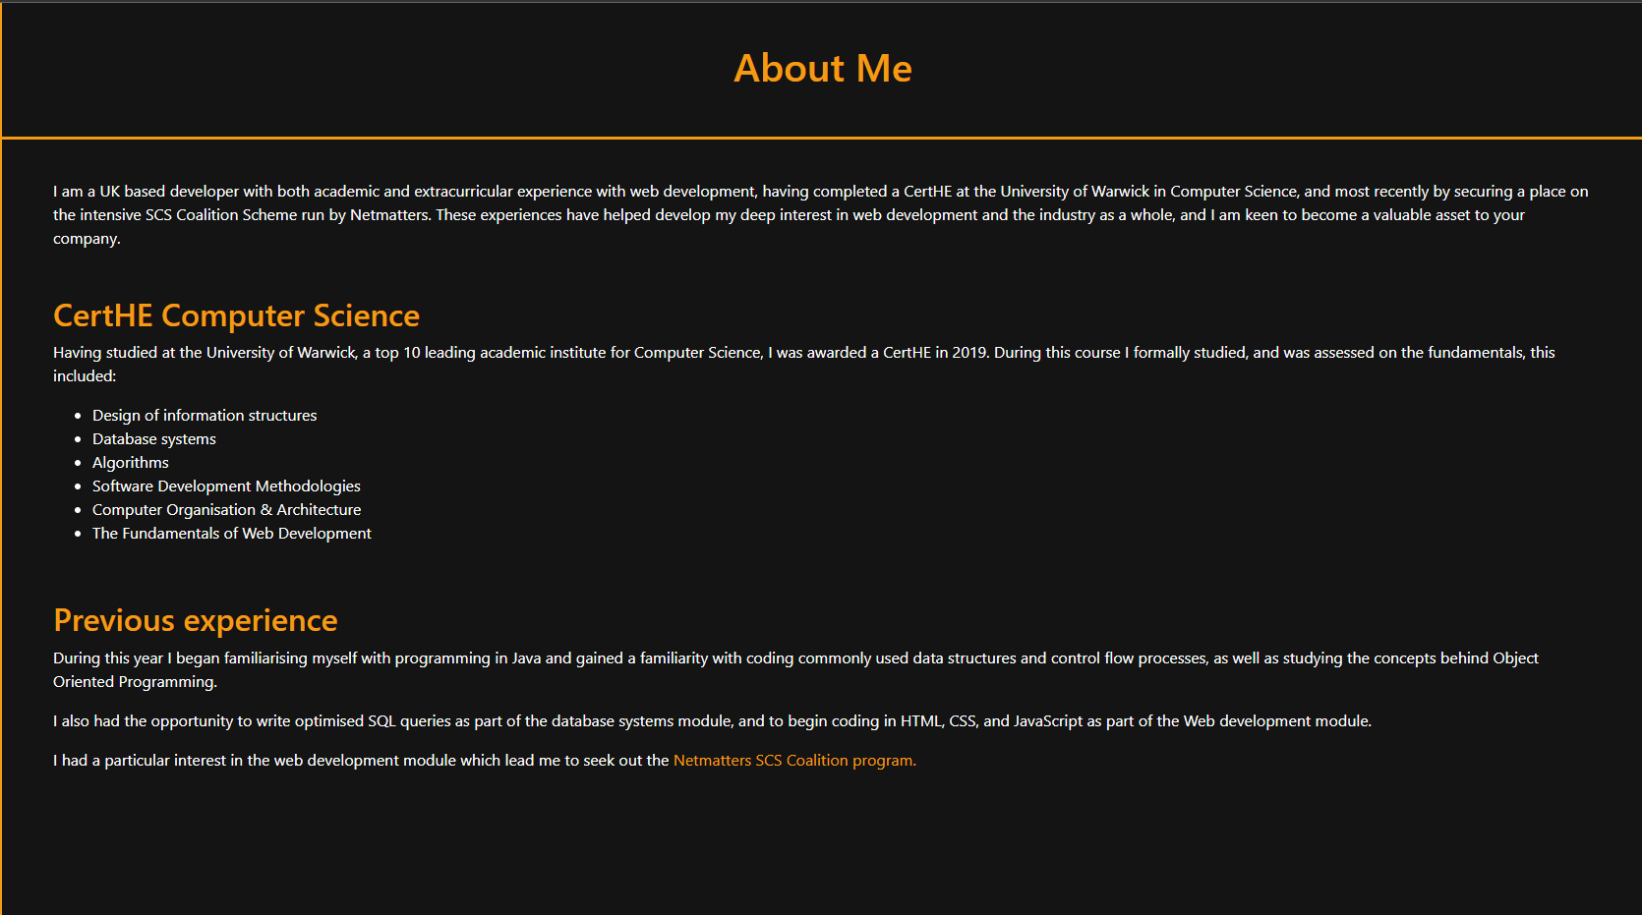

You could then display urls in text using the primary color and have the text use the same hover styles as your side nav menu instead of blue

The hover styles on the project cards needs reviewing – also use ease-in-out on your transition styles to make the transitions smooth on hover and unhover